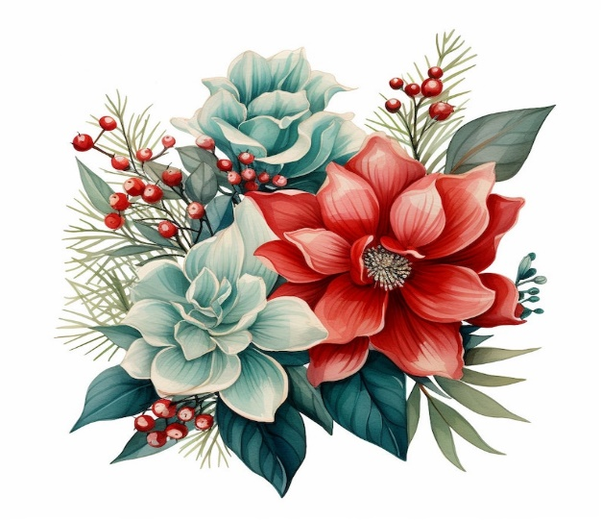
Christmas Craft & Bake Sale

Date: Saturday, November 8th, 2025
Time: 10:00 am – 2:00 pm
Where: Trinity United Church
5013 – 55th Street, Cold Lake, AB (next to KFC)
Items for sale include:
- Baked goods
- Knitted items such as slippers, toques, mittens, scarves, afghans, dish cloths and pan scrubbers
- Quilts, table runners, handbags and other sewn items
- Christmas crafts for home and tree
- Jewellery and many more items
- White elephant table includes gently used Christmas items
Lunch of soup, buns, squares, tea/coffee served - $10.00
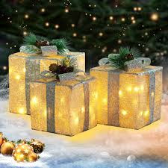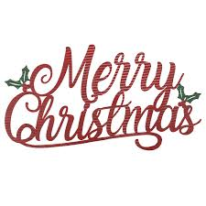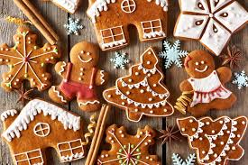

For more information contact:
Carole Butler – 780-573-8356 or Doris McDougall – 780-201-3454

